PRESENT PROPOSED
CASH FLOW & TAXES

Income 701,231 825,342

Plus: Repositioned Assets 0 27,610

Total Cash Income 701,231 852,952

Less: Income Taxes 151,605 159,425

Net Cash Flow Before Expenses 549,626 693,528

Less: Investment Expenses 50,675 80,881

Less: Other Expenses 433,379 529,101

Net Cash Flow 65,571 83,545

CASH FLOW INCREASE (DECREASE) $ 17,974

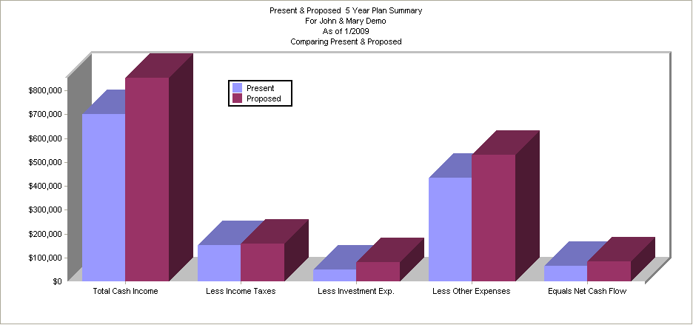

RETIREMENT PLANS

Projected Value Of Retirement Plans 180,401 180,401

RETIREMENT PLAN VALUE INCREASE (DECREASE) $ 0

NET WORTH

Net Worth 1,549,524 1,578,194

NET WORTH INCREASE (DECREASE) $ 28,670

PROFORMA INVESTMENT PERFORMANCE - NOT GUARANTEED

Total New Investments Made Through 2013 30,206

Less: Tax Savings -7,819
OUT-OF-POCKET COST OF INVESTMENTS THROUGH 2013 38,026

PROFORMA VALUE OF NEW INVESTMENTS IN 2013 42,908

